Title: Mental Health in Technology Jobs: A Data-Driven Employee Segmentation Analysis
Course: Machine Learning - Unsupervised Learning and Feature Engineering (DLBDSMLUSL01)
Task: Case Study Task 1
Tutor: Visieu Lac
Student Name: Ijeoma Eze
Matriculation Number: 92131004
Program: BSc. Applied Artificial Intelligence
Date: 26/04/2026
GitHub Link to the Project: NURSEIJ/mental-health-tech-analysis: Unsupervised machine learning analysis of mental health in the technology industry - clustering analysis of OSMI survey data

Contents
LIST OF TABLES 4
LIST OF FIGURES 4
1. INTRODUCTION 5
1.1 Background 5
1.2 Problem Statement 5
1.3 Objectives 6
1.4 Significance of the Study 6
2. LITERATURE REVIEW & INDUSTRY CONTEXT 7
2.1 The Prevalence of Mental Health Issues in Technology 7
2.2 The OSMI Mental Health in Tech Survey 7
2.3 Machine Learning Applications in Mental Health Analysis 8
2.4 Cluster Analysis in Occupational Health 8
2.5 Workplace Factors and Mental Health Outcomes 9
2.6 Research Gap 9
3. METHODOLOGY 9
3.1 Data Source 9
3.2 Data Preprocessing 10
3.3 Clustering Algorithm 10
3.4 Dimensionality Reduction 11
3.5 Ethical Considerations 11
4. DATA ANALYSIS & GENERAL FINDINGS 11
4.1 Dataset Overview 11
4.2 Gender Distribution 12
4.3 Feature Selection 12
4.4 Cluster Quality Assessment 13
4.5 Dimensionality Reduction Visualizations 14
5. DETAILED CLUSTER PROFILES 15
5.1 Cluster Comparison Data 15
5.2 Cluster 0: The Anxious but Aware (30.8% of Workforce) 16
5.3 Cluster 1: The Supported and Open (24.6% of Workforce) 17
5.4 Cluster 2: The Uncertain and Uninformed (44.5% of Workforce) 18
5.5 Comparative Summary of All Clusters 20
6. STRATEGIC RECOMMENDATIONS 20
6.1 Framework for Targeted Interventions 20
6.2 Recommendations for Cluster 0: The Anxious but Aware (30.8% of Workforce) 20
6.3 Recommendations for Cluster 1: The Supported and Open (24.6% of Workforce) 21
6.4 Recommendations for Cluster 2: The Uncertain and Uninformed (44.5% of Workforce) 22
6.5 Organization-Wide Recommendations 23
6.6 Expected Outcomes 24
7. LIMITATIONS 24
8. CONCLUSION 25
8.1 Summary of Findings 25
8.2 Key Takeaways for HR Leadership 25
8.3 Closing Statement 25
9. BIBLIOGRAPHY 26

LIST OF TABLES
Table 1: Dataset Overview After Preprocessing 11
Table 2: Gender Distribution After Standardization 12
Table 3: Selected Features for Clustering Analysis 12
Table 4: Cluster Quality Scores 13
Table 5: Cluster Size Distribution 15
Table 6: Cluster 0 - Key Characteristics Profile 16
Table 7: Cluster 1 - Key Characteristics Profile 17
Table 8: Cluster 2 - Key Characteristics Profile 18
Table 9: Comparative Summary of All Clusters 20
Table 10:Recommendation for Cluster 0 21
Table 11:Recommendation for Cluster 1 22
Table 12:Recommendation for Cluster 2 22

LIST OF FIGURES
Figure 1: Elbow Method and Silhouette Score for Optimal Cluster Selection 14
Figure 2: PCA Visualization of Employee Clusters 14
Figure 3: t-SNE Visualization of Employee Clusters 15
Figure 4: Distribution of Employees Across Clusters 16

1. INTRODUCTION

1.1 Background
The technology industry has emerged as a cornerstone of the global economy, yet it faces a paradox: while driving innovation and productivity, it simultaneously harbors significant mental health challenges among its workforce. Research indicates that "the IT industry, in particular, has been found to have higher rates of mental health issues" (Grishan, 2023). The unique pressures facing technology workers include high-performance expectations, prolonged screen time, rapid technological change, and workplace cultures that may inadvertently stigmatize help-seeking behavior.
The World Health Organization reports that "an estimated 264 million people suffer from depression," with many experiencing concurrent anxiety symptoms (Kaaria & Mwaruta, 2023). Furthermore, "the lost productivity cost for depression and anxiety disorders adds up to 1 trillion US dollars globally each year" (Kaaria & Mwaruta, 2023). This economic impact has led employers to focus increasingly on presenteeism—"decreased productivity because of health problems—among employees who remain present at work" (Kaaria & Mwaruta, 2023).

1.2 Problem Statement
The Human Resources department has recognized the need for a proactive, data-driven approach to mental health support. However, working with survey data presents significant challenges due to its high dimensionality, complexity, missing values, and non-standardized textual inputs. Without proper analysis, it is not straightforward to interpret and transfer the results to organizational structures.

1.3 Objectives
This study aims to:
- Categorize participants of the survey according to their answers using unsupervised machine learning
- Provide visualizations supporting the interpretation of identified clusters
- Convey a perspective onto the dataset that is reduced in complexity while preserving main characteristics
- Provide insight into each individual cluster and its main characteristics
- Identify potential points of leverage for targeted HR interventions

1.4 Significance of the Study
As Sharma et al. (2025) note, "the place of employment can have a significant influence on your general state of health and happiness." This study directly supports the observation that "employees in excellent mental health regulate the daily responsibilities and pressures of work, build healthy relationships with fellow workers, and alleviate everyone they interact with respect" (Sharma et al., 2025). By identifying distinct employee segments, HR can develop targeted interventions that address specific needs rather than applying one-size-fits-all solutions.

2. LITERATURE REVIEW & INDUSTRY CONTEXT

2.1 The Prevalence of Mental Health Issues in Technology
The technology industry presents unique mental health challenges. According to Grishan (2023), "the IT industry, in particular, has been found to have higher rates of mental health issues according to research conducted by Open Sourcing Mental Illness (OSMI)." This elevated prevalence may be attributed to several industry-specific factors:
Factor | Description | Potential Impact
Technostress | Stress induced by rapid technological change | Increased anxiety, burnout
Workload Intensification | High-performance expectations | Sleep disorders, depression
Remote Work Challenges | Isolation, blurred boundaries | Social withdrawal, loneliness
Skill Obsolescence Fear | Constant need for upskilling | Imposter syndrome, chronic anxiety

Patel et al. (2025) further elaborate that "driven by artificial intelligence and automation, the rising speed of digital transformation presents fresh difficulties for the mental health of IT workers. With specific attention to stress and burnout, this study investigates the effects of technostress, fast upskill demands, workload intensification, and remote work on the psychological health of IT professionals."

2.2 The OSMI Mental Health in Tech Survey
The Open Sourcing Mental Illness (OSMI) survey serves as a foundational dataset for understanding mental health in the technology workplace. According to OSMI documentation, the survey "aims to measure attitudes towards mental health in the tech workplace, and examine the frequency of mental health disorders among the tech industry" (OSMI, 2016).
Ramesh Naidu et al. (2025) describe the dataset's utility: "Leveraging data from the OSMI Mental Health in Tech Survey, the study employs rigorous Exploratory Data Analysis (EDA) and meticulous preprocessing techniques to ensure the relevance and reliability of the dataset."

2.3 Machine Learning Applications in Mental Health Analysis
The application of machine learning to mental health analysis has gained significant research attention. Sharma et al. (2025) observe that "researchers are investigating the use of applications that utilize ML in reaction to the increase in mental wellness problems and the popularity of improved healthcare."
Grishan (2023) confirms "the effectiveness of employing machine learning techniques in analyzing employees' mental health in the IT industry." Ramesh Naidu et al. (2025) present "a comprehensive framework for the development of a sophisticated mental health assessment system tailored specifically for the technology industry."

2.4 Cluster Analysis in Occupational Health
Cluster analysis has emerged as a valuable methodology for identifying distinct employee subgroups. Anttila et al. (2025) note that "clustering methods may reveal possible structures in the data in a data-driven way without pre-established hypotheses."
Their research successfully identified "six clinically coherent employee clusters, providing information on typical combinations of characteristics and risk profiles of sickness absence" (Anttila et al., 2025). They further argue that such "previously unidentified employee profiles...could provide valuable information for occupational health professionals in planning appropriate personalized interventions targeted at the specific properties of each cluster."

2.5 Workplace Factors and Mental Health Outcomes
Rehman et al. (2025) identified key workplace determinants: "Findings revealed that conscientiousness and self-regulation negatively predicted cyberslacking, whereas neuroticism and perceived technostress were positive predictors." This highlights the importance of understanding personality and stressor dynamics in IT workplaces.
Patel et al. (2025) emphasize practical applications: "The results have pragmatic ramifications for HR and organizational leaders using data-driven mental health approaches to create better, more resilient digital workplaces."

2.6 Research Gap
Despite growing research attention, gaps remain in translating clustering findings into actionable HR interventions. This study addresses this gap by not only identifying employee clusters but also providing specific, targeted recommendations for each segment.

3. METHODOLOGY

3.1 Data Source
This analysis utilized the OSMI Mental Health in Tech Survey 2016 dataset, containing 1,433 responses from technology industry employees across 63 questions. The dataset examines various dimensions of workplace mental health, including employer-provided benefits, comfort levels with disclosure, perceived consequences, and personal mental health history.

3.2 Data Preprocessing
Following the framework established by Ramesh Naidu et al. (2025), the analysis employed "rigorous Exploratory Data Analysis (EDA) and meticulous preprocessing techniques to ensure the relevance and reliability of the dataset."
Step 1: Removal of High-Missing Columns
Columns with more than 50% missing values were removed. This primarily affected questions that only applied to non-self-employed respondents, resulting in the removal of 13 columns (20.6% of total).
Step 2: Gender Standardization
The gender column contained over 70 unique text entries (e.g., "Male," "male," "M," "cis male"). A standardization function consolidated these into six categories: Male, Female, Non-binary, Transgender, Other, and Unknown.
Step 3: Feature Selection
Twelve questions were selected for clustering based on their relevance to workplace mental health attitudes and experiences.
Step 4: Missing Value Imputation
Remaining missing values were filled with "No answer" to maintain data intergrity while preserving information about non-response.
Step 5: Encoding and Scaling
Categorical responses were converted to numerical values using Label Encoding, followed by Standard Scaling to ensure all features contributed equally to the clustering algorithm.

3.3 Clustering Algorithm
K-means clustering was selected for its interpretability and computational efficiency. As Anttila et al. (2025) describe, "clusters were calculated using the K-means algorithm from datapoints expressed by the resulting principal components."
The optimal number of clusters was determined using the silhouette score method, which measures how similar an object is to its own cluster compared to other clusters. Higher silhouette scores indicate better-defined clusters.

3.4 Dimensionality Reduction
Principal Component Analysis (PCA) and t-Distributed Stochastic Neighbor Embedding (t-SNE) were employed to visualize the high-dimensional data in two dimensions. PCA was used for its interpretability of variance, while t-SNE was used to reveal potential cluster structures.

3.5 Ethical Considerations
All analysis was conducted on anonymized survey data. No personally identifiable information was used. The analysis focuses on aggregate patterns rather than individual responses.

4. DATA ANALYSIS & GENERAL FINDINGS

4.1 Dataset Overview
After preprocessing, the dataset was prepared for clustering analysis with the following characteristics:
Table 1: Dataset Overview After Preprocessing
Metric | Value
Total respondents (original) | 1,433
Total questions (original) | 63
Columns removed (>50% missing) | 13
Final features for clustering | 12
Final dataset shape | 1,433 × 12

4.2 Gender Distribution
The gender standardization process consolidated 70+ unique entries into six categories:
Table 2: Gender Distribution After Standardization
Gender Category | Count | Percentage
Male | 1,048 | 73.2%
Female | 330 | 23.0%
Other | 36 | 2.5%
Non-binary | 12 | 0.8%
Transgender | 4 | 0.3%
Unknown | 3 | 0.2%
Total | 1,433 | 100%

This distribution is consistent with the technology industry's demographic profile and should be considered when interpreting cluster characteristics and designing interventions.

4.3 Feature Selection
Table 3: Selected Features for Clustering Analysis
# | Question | Domain
1 | Does your employer provide mental health benefits as part of healthcare coverage? | Benefits Access
2 | Do you know the options for mental health care available under your employer-provided coverage? | Awareness
3 | Has your employer ever formally discussed mental health? | Communication
4 | Would you feel comfortable discussing a mental health disorder with your direct supervisor(s)? | Comfort (Supervisor)
5 | Would you feel comfortable discussing a mental health disorder with your coworkers? | Comfort (Peers)
6 | Do you think that discussing a mental health disorder with your employer would have negative consequences? | Fear/Stigma
7 | Do you feel that your employer takes mental health as seriously as physical health? | Perceived Support
8 | Have you heard of or observed negative consequences for co-workers who have been open about mental health issues? | Observed Stigma
9 | Do you currently have a mental health disorder? | Personal Experience
10 | Have you ever sought treatment for a mental health issue from a mental health professional? | Help-seeking
11 | Do you feel that being identified as a person with a mental health issue would hurt your career? | Career Fear
12 | How willing would you be to share with friends and family that you have a mental illness? | Disclosure Willingness

4.4 Cluster Quality Assessment
The elbow method and silhouette score were used to determine the optimal number of clusters.
Table 4: Cluster Quality Scores
Number of Clusters (k) | Inertia (Within-cluster distance) | Silhouette Score
2 | 14,725 | 0.148
3 | 13,569 | 0.142
4 | 12,579 | 0.142
5 | 11,942 | 0.148
6 | 11,348 | 0.157
7 | 10,862 | 0.160
8 | 10,498 | 0.134

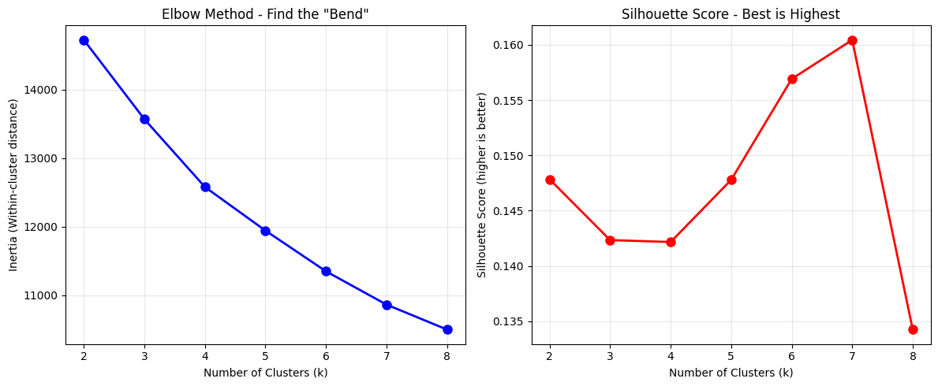
Figure 1: Elbow Method and Silhouette Score for Optimal Cluster Selection
While the silhouette score suggested k=7 as statistically optimal (score: 0.160), interpretability considerations led to the selection of k=3 clusters. As Anttila et al. (2025) note, the value of clustering lies in providing "information for occupational health professionals in planning appropriate personalized interventions targeted at the specific properties of each cluster." Three clusters provided clearer, more actionable segments for HR intervention.

4.5 Dimensionality Reduction Visualizations
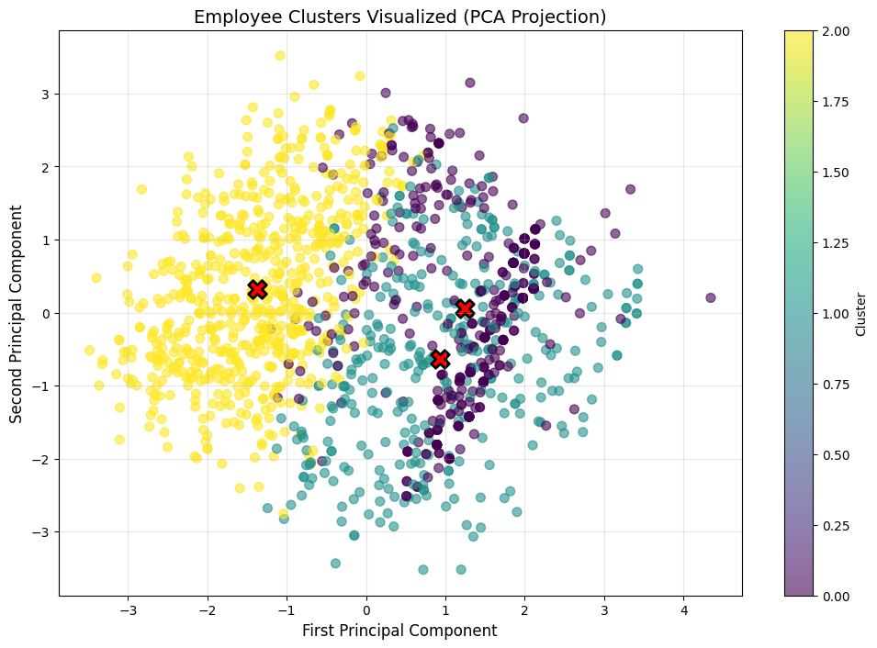
Figure 2: PCA Visualization of Employee Clusters
Interpretation: The PCA visualization shows three distinguishable clusters with some overlap, suggesting that while distinct groups exist, attitudes exist on a spectrum rather than in completely isolated categories.
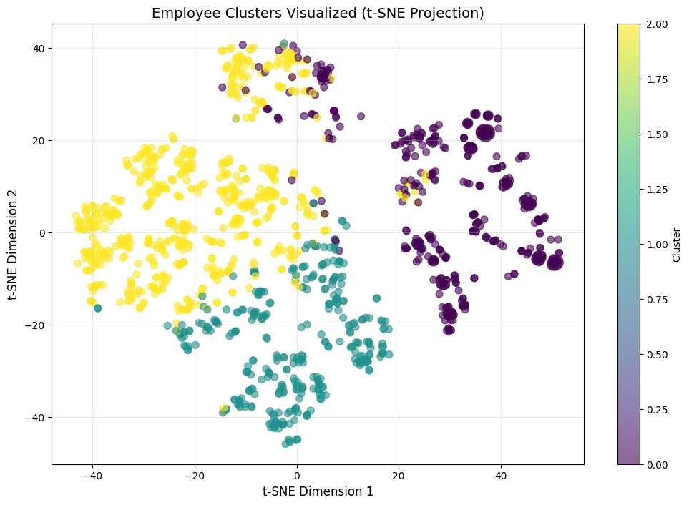
Figure 3: t-SNE Visualization of Employee Clusters
Interpretation: The t-SNE projection reveals clearer boundaries between clusters, confirming the validity of the three-group solution.

5. DETAILED CLUSTER PROFILES

5.1 Cluster Comparison Data
Table 5: Cluster Size Distribution
Cluster | Size | Percentage of Workforce
Cluster 0 | 442 | 30.8%
Cluster 1 | 353 | 24.6%
Cluster 2 | 638 | 44.5%
Total | 1,433 | 100%

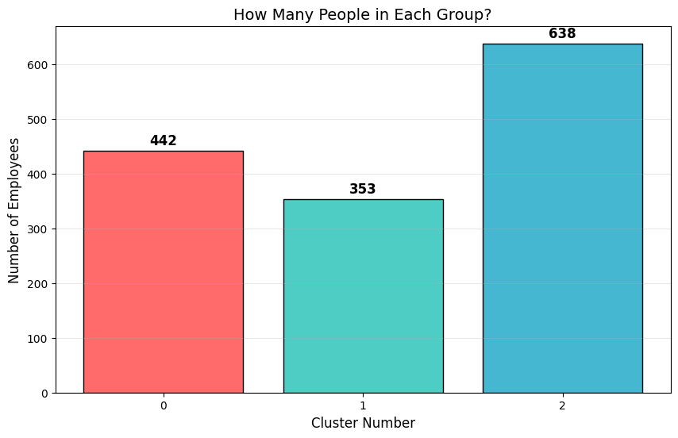
Figure 4: Distribution of Employees Across Clusters

5.2 Cluster 0: The Anxious but Aware (30.8% of Workforce)
Table 6: Cluster 0 - Key Characteristics Profile
Characteristic | Modal Response | Interpretation
Mental health benefits available | Yes | Benefits exist
Knows available options | Yes | Aware of resources
Employer discussed mental health | No | No formal communication
Comfortable with supervisor | No | High discomfort
Comfortable with coworkers | No | High discomfort
Fears negative consequences | Yes | High fear
Employer takes mental health seriously | No | Perceives low support
Heard of negative consequences | Yes | Aware of stigma
Currently has mental health disorder | Yes (215/442) | High prevalence
Sought treatment | Yes (308/442) | High help-seeking
Believes disclosure hurts career | Yes | High career fear
Willing to share with family/friends | Somewhat open | Moderate disclosure

Profile Summary:
Cluster 0 employees have access to mental health benefits and know their options, yet report that their employers have not formally discussed mental health. Despite having benefits, they lack comfort discussing mental health with supervisors or coworkers and fear negative career consequences.
This cluster has the highest rate of current mental health disorders among all groups (215 out of 442, approximately 49%). They also show the highest rate of treatment-seeking behavior (308 out of 442, approximately 70%), indicating that many are actively managing mental health conditions but do not feel supported in the workplace.
The combination of high disorder prevalence, high treatment-seeking, and high fear of disclosure suggests a population that is managing mental health personally but lacks workplace psychological safety.

Key Insight: As Rehman et al. (2025) found, "perceived technostress" can be a positive predictor of negative outcomes. For Cluster 0, the perceived workplace environment may be exacerbating rather than alleviating mental health challenges.

5.3 Cluster 1: The Supported and Open (24.6% of Workforce)
Table 7: Cluster 1 - Key Characteristics Profile
Characteristic | Modal Response | Interpretation
Mental health benefits available | Yes | Benefits exist
Knows available options | Yes | Aware of resources
Employer discussed mental health | No | No formal communication
Comfortable with supervisor | Yes | High Comfort
Comfortable with coworkers | Yes | High Comfort
Fears negative consequences | No | Low fear
Employer takes mental health seriously | Yes | Perceives Support
Heard of negative consequences | No | No observed stigma
Currently has mental health disorder | Mixed (147 Yes, 146 No) | Balanced
Sought treatment | Yes (201/353) | Moderate help-seeking
Believes disclosure hurts career | Maybe (most common) | Moderate uncertainty
Willing to share with family/friends | Somewhat open | Moderate disclosure

Profile Summary:
Cluster 1 employees have access to benefits and feel comfortable discussing mental health at work. They do not fear negative consequences and perceive their employers as taking mental health seriously. Despite having the lowest rate of fearing career consequences among all clusters, they remain somewhat cautious about disclosure, with "Maybe" being the most common response regarding whether disclosure would hurt their careers.
This group has a balanced distribution of current mental health disorders (147 Yes, 146 No) and moderate treatment-seeking behavior (201 out of 353, approximately 57%). Notably, none of the employees in this cluster reported having heard of or observed negative consequences for co-workers who were open about mental health issues.
Key Insight: This cluster represents an opportunity for peer mentorship and ambassador programs. As Patel et al. (2025) suggest, these results have "pragmatic ramifications for HR and organizational leaders using data-driven mental health approaches."

5.4 Cluster 2: The Uncertain and Uninformed (44.5% of Workforce)
Table 8: Cluster 2 - Key Characteristics Profile
Characteristic | Modal Response | Interpretation
Mental health benefits available | Yes | Benefits exist
Knows available options | No | Unaware of resources
Employer discussed mental health | No | No formal communication
Comfortable with supervisor | Maybe | Ambivalent
Comfortable with coworkers | Maybe | Ambivalent
Fears negative consequences | Maybe | Ambivalent
Employer takes mental health seriously | I don't know | Uncertain
Heard of negative consequences | No | No observed stigma
Currently has mental health disorder | No (most common) | Lower prevalence
Sought treatment | Mixed (330 Yes, 308 No) | Balanced
Believes disclosure hurts career | Yes | High career fear
Willing to share with family/friends | Somewhat open | Moderate disclosure

Profile Summary:
Cluster 2 is the largest group, representing nearly half of the workforce (44.5%). These employees have access to benefits but lack knowledge about available options. Their employers have not discussed mental health formally. They express uncertainty across most metrics—uncertain about comfort levels, uncertain about consequences, and uncertain about whether their employer takes mental health seriously.
This cluster has the lowest rate of current mental health disorders (264 No, 213 Yes, 161 Maybe) and balanced treatment-seeking behavior (330 Yes, 308 No). However, despite lower personal experience with mental health disorders, they still express high career fear regarding disclosure.
Key Insight: This group represents a significant opportunity for education and outreach. As Anttila et al. (2025) argue, these "previously unidentified employee profiles...could provide valuable information for occupational health professionals in planning appropriate personalized interventions."

5.5 Comparative Summary of All Clusters
Table 9: Comparative Summary of All Clusters
Dimension | Cluster 0 (30.8%) | Cluster 1 (24.6%) | Cluster 2 (44.5%)
Benefits Access | Yes | Yes | Yes
Awareness | High | High | Low
Comfort Level | Low | High | Ambivalent
Fear Level | High | Low | Ambivalent
Perceived Support | Low | High | Uncertain
Disorder Prevalence | High (49%) | Balanced (42%) | Lower (33%)
Treatment-Seeking | High (70%) | Moderate (57%) | Balanced (51%)
Primary Need | Psychological safety | Engagement/Leadership | Education/Awareness

6. STRATEGIC RECOMMENDATIONS

6.1 Framework for Targeted Interventions
Based on the cluster profiles identified, the following recommendations are organized by cluster. As Anttila et al. (2025) recommend, interventions should be "personalized interventions targeted at the specific properties of each cluster."

6.2 Recommendations for Cluster 0: The Anxious but Aware (30.8% of Workforce)
Primary Need: Psychological safety and stigma reduction

Table 10:Recommendation for Cluster 0
Priority | Recommendation | Rationale | Expected Impact
HIGH | Implement anonymous mental health support channels | Cluster 0 fears negative consequences | Reduced fear, increased utilization
HIGH | Provide manager training on compassionate communication | Low comfort with supervisors | Improved supervisor relationships
HIGH | Establish clear anti-retaliation policies | High fear of career consequences | Increased psychological safety
MEDIUM | Create peer support groups | Low comfort with coworkers | Built community and reduced isolation
MEDIUM | Share anonymous success stories of disclosure | High fear, high help-seeking | Normalized help-seeking behavior

Specific Actions for Cluster 0:
- Anonymous Counseling Services: Contract with an external Employee Assistance Program (EAP) that guarantees anonymity
- Manager Mental Health Training: Train all managers on recognizing distress, conducting supportive conversations, and referring to resources without judgment
- Protected Disclosure Policies: Develop and communicate explicit policies protecting employees who seek mental health support from adverse career consequences
- Peer Support Networks: Train volunteer employees (prioritize Cluster 1 members) as mental health first aiders

6.3 Recommendations for Cluster 1: The Supported and Open (24.6% of Workforce)
Primary Need: Engagement and leadership development
Table 11:Recommendation for Cluster 1
Priority | Recommendation | Rationale | Expected Impact
HIGH | Leverage as mental health ambassadors | High comfort, low fear, no observed stigma | Peer influence on other clusters
HIGH | Feature in company communications | Positive attitudes toward mental health | Destigmatization
MEDIUM | Gather feedback on current programs | High awareness and utilization | Improved existing resources
LOW | Recruit for pilot program participation | High engagement | Test new initiatives effectively

Specific Actions for Cluster 1:
- Mental Health Ambassador Program: Recruit Cluster 1 employees as volunteer ambassadors to share experiences (anonymously or identified) and promote available resources
- Focus Group Participation: Invite Cluster 1 employees to participate in focus groups to evaluate current mental health programs and suggest improvements
- Recognition and Reward: Acknowledge Cluster 1 employees who contribute to mental health initiatives through company recognition programs

6.4 Recommendations for Cluster 2: The Uncertain and Uninformed (44.5% of Workforce)
Primary Need: Education and awareness
Table 12:Recommendation for Cluster 2
Priority | Recommendation | Rationale | Expected Impact
HIGH | Launch company-wide mental health awareness campaign | Low awareness, high uncertainty | Increased knowledge, reduced uncertainty
HIGH | Clarify existing mental health policies and benefits | Low knowledge of options | Improved access to information
HIGH | Host all-hands meetings with mental health focus | Large cluster size, uncertainty at scale | Demonstrated organizational commitment
MEDIUM | Distribute easy-to-understand resource guides | Low awareness | Improved access to information
MEDIUM | Offer manager training for mental health conversations | Ambivalent comfort levels | Built comfort across the organization

Specific Actions for Cluster 2:
- Mental Health Education Campaign: Launch a multi-channel campaign (email, intranet, posters, all-hands meetings) explaining available benefits, how to access them, and confidentiality protections
- Benefits Guide: Create a one-page, easy-to-understand guide to mental health benefits and distribute to all employees
- Q&A Sessions: Host anonymous Q&A sessions where employees can ask questions about mental health resources without identifying themselves
- Manager Communication Training: Train managers to proactively communicate about available resources and normalize help-seeking

6.5 Organization-Wide Recommendations
Beyond cluster-specific interventions, the following organization-wide initiatives are recommended:
- Annual Mental Health Survey: Repeat this analysis annually to track changes over time and adjust interventions based on evolving needs
- Mental Health Task Force: Establish a cross-functional task force with representatives from all three clusters to guide mental health strategy
- Integration with DEI Initiatives: Incorporate mental health into diversity, equity, and inclusion (DEI) initiatives, recognizing that mental health conditions are protected under disability laws in many jurisdictions
- Leadership Commitment: Secure executive sponsorship for mental health initiatives and communicate leadership commitment regularly
- Metrics and Accountability: Establish clear metrics for mental health program success (e.g., utilization rates, employee satisfaction, retention) and hold leaders accountable

6.6 Expected Outcomes
Based on the literature, successful implementation of these recommendations could yield significant returns. As Kaaria & Mwaruta (2023) note, research indicates that "every dollar invested in stepping up treatment (or prevention) for common MIs (e.g., depression and anxiety) leads to a fourfold return in better health and the passion or the capability to work."

7. LIMITATIONS
- Self-reported data: Responses may be subject to social desirability bias or recall bias leading to potential over- or under-reporting of mental health issues
- Cross-sectional design: Data collected at single time point cannot assess causality or trends over time

- Sampling bias: Voluntary response survey was not randomly sampled and so may overrepresent individuals with strong opinions or personal experience with mental health issues
- Industry specificity: Data limited to technology industry can lead to limited generalizability to other sectors
- Missing data: 13 columns removed due to >50% missing values leading to some information lost
- Data age: 2016 dataset may not reflect current conditions and may produce potential outdated responses

8. CONCLUSION

8.1 Summary of Findings
This analysis successfully identified three distinct employee clusters based on mental health attitudes and experiences in the technology workplace:
- Cluster 0 (The Anxious but Aware - 30.8%): Employees with access to benefits and awareness of options, but low comfort with disclosure and high fear of negative consequences. This group has the highest prevalence of current mental health disorders and treatment-seeking behavior.
- Cluster 1 (The Supported and Open - 24.6%): Employees with access to benefits, high comfort with disclosure, and low fear of consequences. This group represents a potential resource for peer support and leadership in mental health initiatives.
- Cluster 2 (The Uncertain and Uninformed - 44.5%): The largest cluster, characterized by uncertainty across most metrics and low awareness of available options despite having access to benefits.

8.2 Key Takeaways for HR Leadership
Access is not enough: Employees need awareness, comfort, and trust to utilize mental health resources
Communication is critical: Most employees report that employers have not formally discussed mental health
Fear persists: Concerns about career consequences remain a significant barrier to seeking help
Uncertainty dominates: Nearly half the workforce is neither comfortable nor uncomfortable—they simply lack information
Targeted approaches are needed: Each cluster requires different interventions

8.3 Closing Statement
As Sharma et al. (2025) eloquently state, "the place of employment can have a significant influence on your general state of health and happiness. In addition to financial rewards, your job might give your existence purpose, direction, and significance."
By adopting a data-driven, targeted approach to mental health support, organizations can fulfill their responsibility to provide "a safe and secure work environment" (Sharma et al., 2025) for all employees. The clusters identified in this analysis provide a roadmap for moving from one-size-fits-all interventions to personalized, effective support that addresses the specific needs of each employee segment.
The recommendations provided offer a practical framework for HR leadership to:
- Immediately address the needs of high-risk clusters
- Leverage supportive clusters as ambassadors
- Educate the uncertain majority
- Build a culture where mental health is discussed openly and support is readily available
Through sustained commitment and data-driven refinement of interventions, organizations can create workplaces where all employees—regardless of mental health status—can thrive.

9. BIBLIOGRAPHY
Anttila, A., Nuutinen, M., Leskelä, R-L., van Gils, M., Pekki, A., & Sauni, R. (2025). Cluster analysis reveals subgroups with different risk profiles and sickness absence patterns in an occupational health cohort. Journal of Occupational Rehabilitation. Advance online publication. https://doi.org/10.1007/s10926-025-10319-x
Grishan, A. (2023). Using machine learning methods to analyze the mental health of employees in IT industry [Bachelor's thesis]. National Research University Higher School of Economics.
Harvard Business Review. (2019). The stigma of mental illness in high-performance cultures. https://hbr.org
Kaaria, A., & Mwaruta, S. (2023). Mental health ingenuities and the role of computer technology on employees' mental health: A systematic review. East African Journal of Health and Science, 6(1), 1-15.
Open Sourcing Mental Illness (OSMI). (2016). Mental health in tech survey 2016. OpenML. https://www.openml.org/search?type=data&id=42193
Patel, T., Jhaveri, R. H., & Bvuma, S. (2025). Analyzing the impact of digital transformation on mental health of IT professionals using machine learning methods. In S. B. Patel, S. K. Bharti, & A. Choudhury (Eds.), 2025 International Conference on Artificial Intelligence and Machine Vision (AIMV). IEEE.
Ramesh Naidu, P., Karthik, K., & Kirana, K. (2025). Predicting psychological instability using the ensemble model. In AIP Conference Proceedings. Taylor & Francis. https://doi.org/10.1201/9781003515470-52
Rehman, S., Zubair, A., & Javed, M. (2025). Personality as determinants of cyberslacking behaviors among IT professionals: Moderating role of perceived technostress and self-regulation. BPA. Advance online publication. https://doi.org/10.26387/bpa.2025.00011
Sharma, S., Ghantasala, G. S. P., Gupta, V., Sarangi, P. K., R, R. S., & Sungheetha, A. (2025). Analyzing employees' mental health using machine learning algorithms. In 2025 12th International Conference on Reliability, Infocom Technologies and Optimization (ICRITO) (pp. 1-5). IEEE. https://doi.org/10.1109/ICRITO66076.2025.11241431

